Application Deployment
(Deploy the given React application to a production ready state)

Application:
Clone the below mentioned repository and deploy the application (Run application in port 3000).
Repo URL : https://github.com/Vennilavanguvi/Brain-Tasks-App.git

Docker:
- Dockerize the application by creating Dockerfile
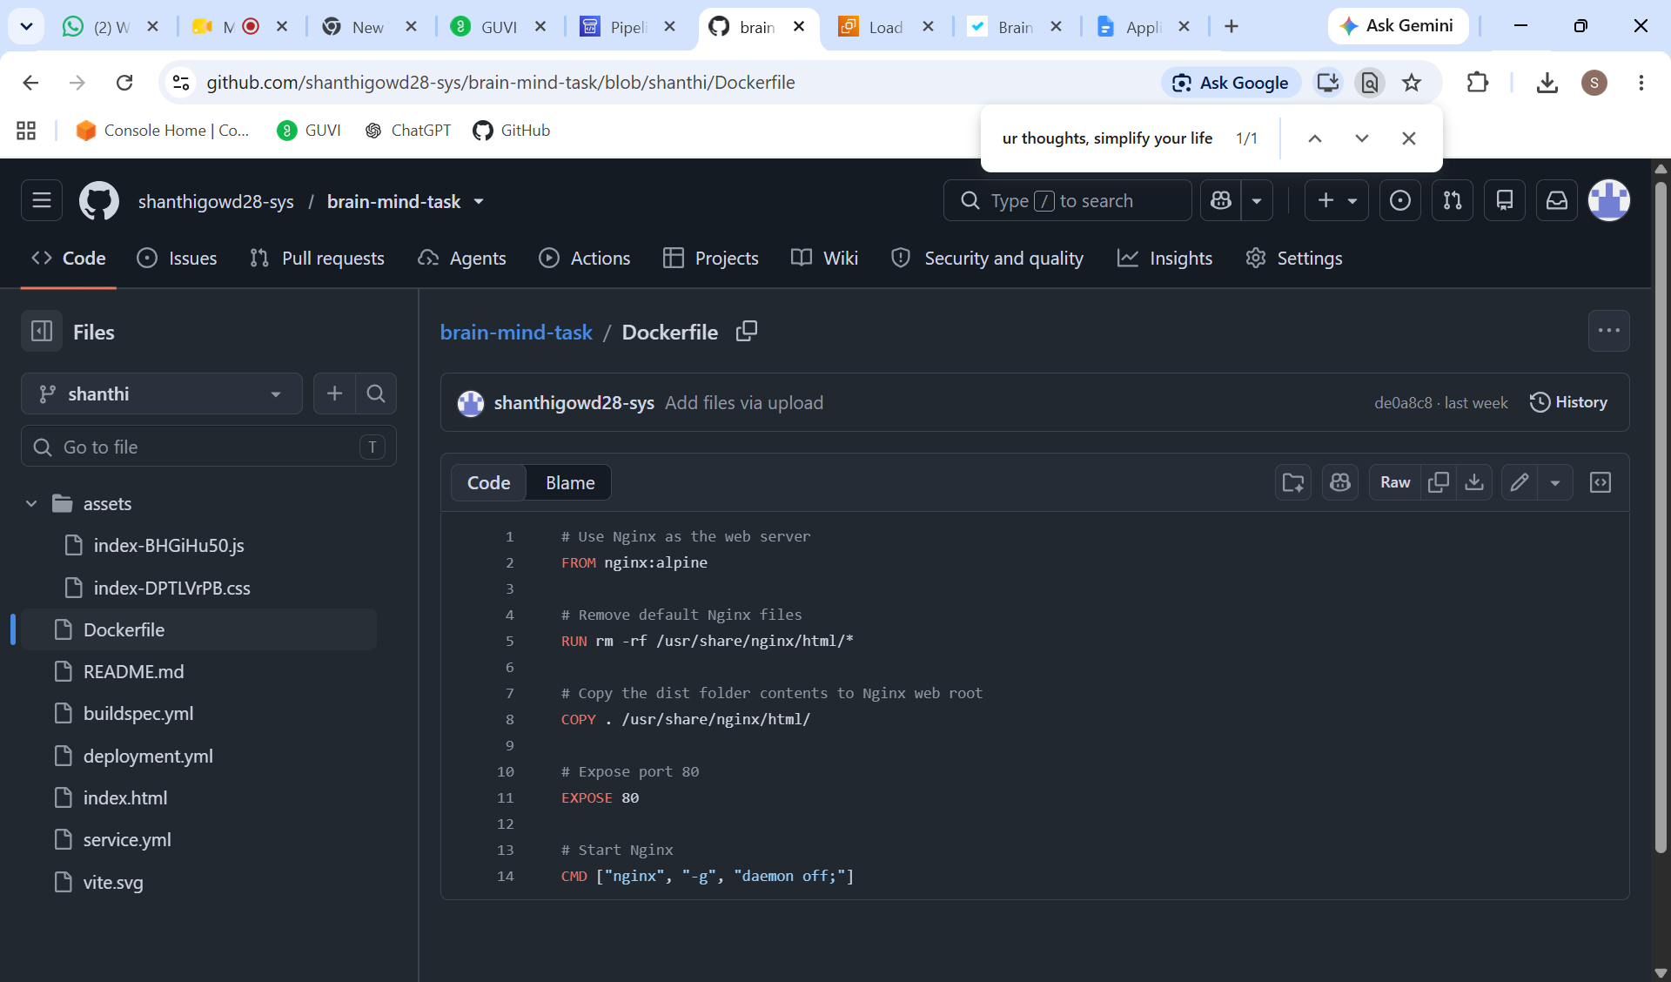
- Build an application and check output using docker image.
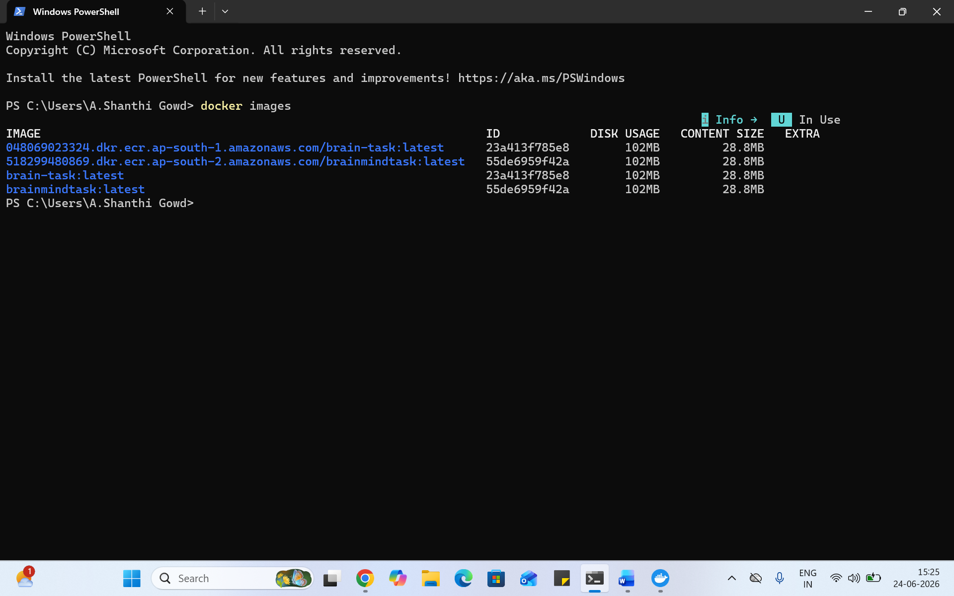
Registry:
- Create an AWS ECR or Dockerhub repository for storing docker images.
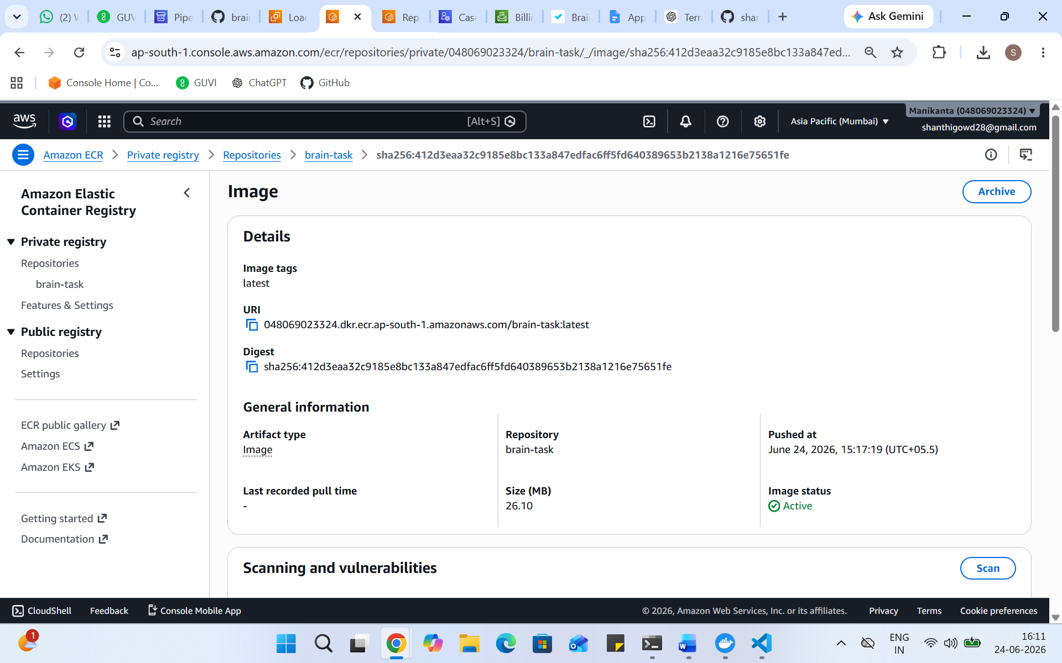

Kubernetes:
- Setup Kubernetes in AWS EKS and Confirm EKS cluster is running.
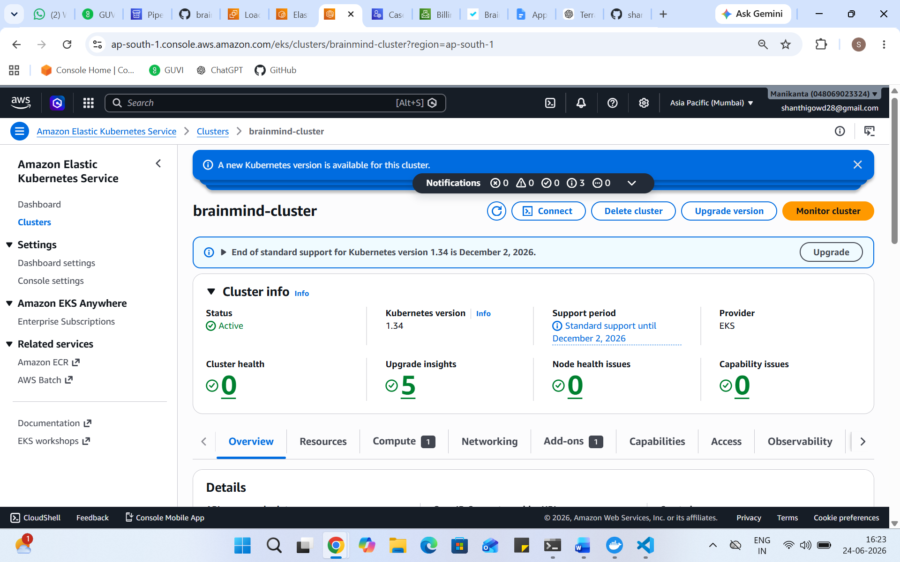
- Write deployment and service YAML files.
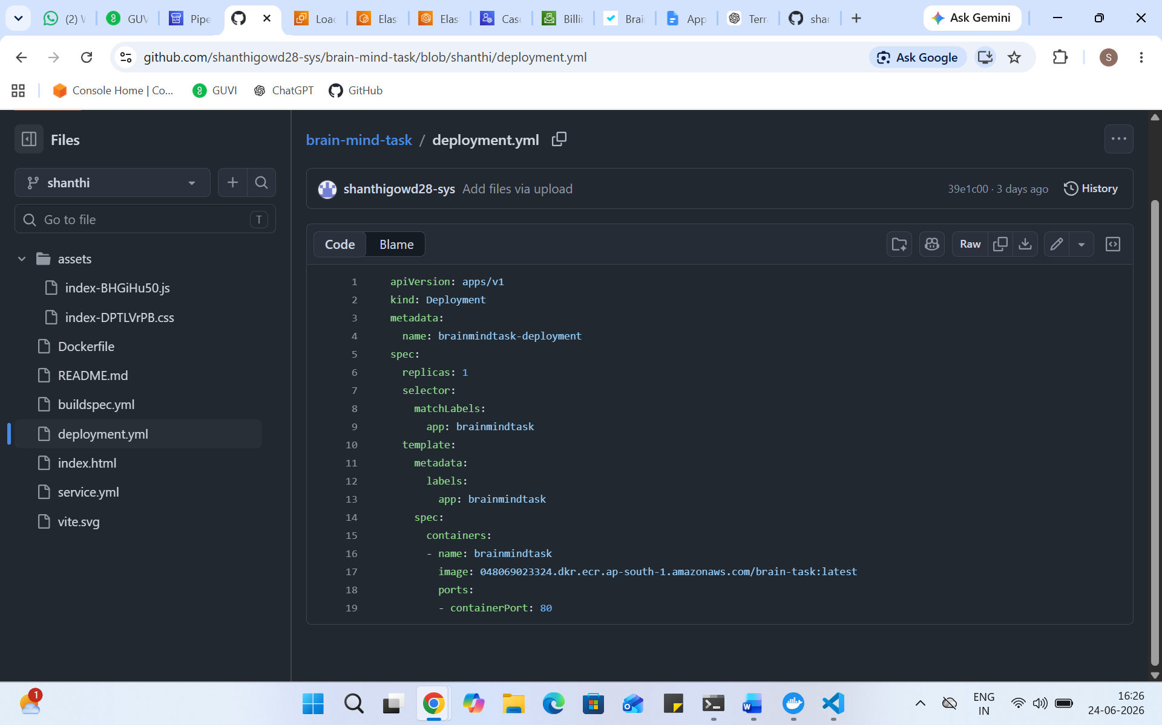
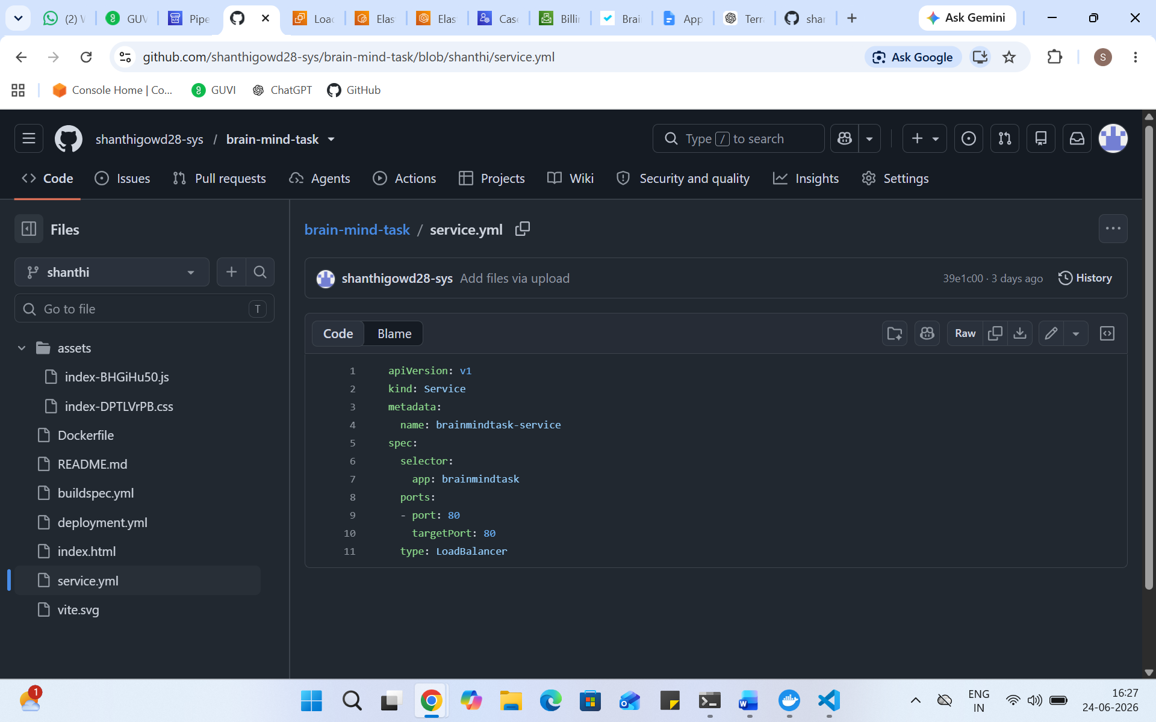

- Deploy using kubectl via CodeBuild or Codepipeline.

CodeBuild:
- Create a CodeBuild project:
- 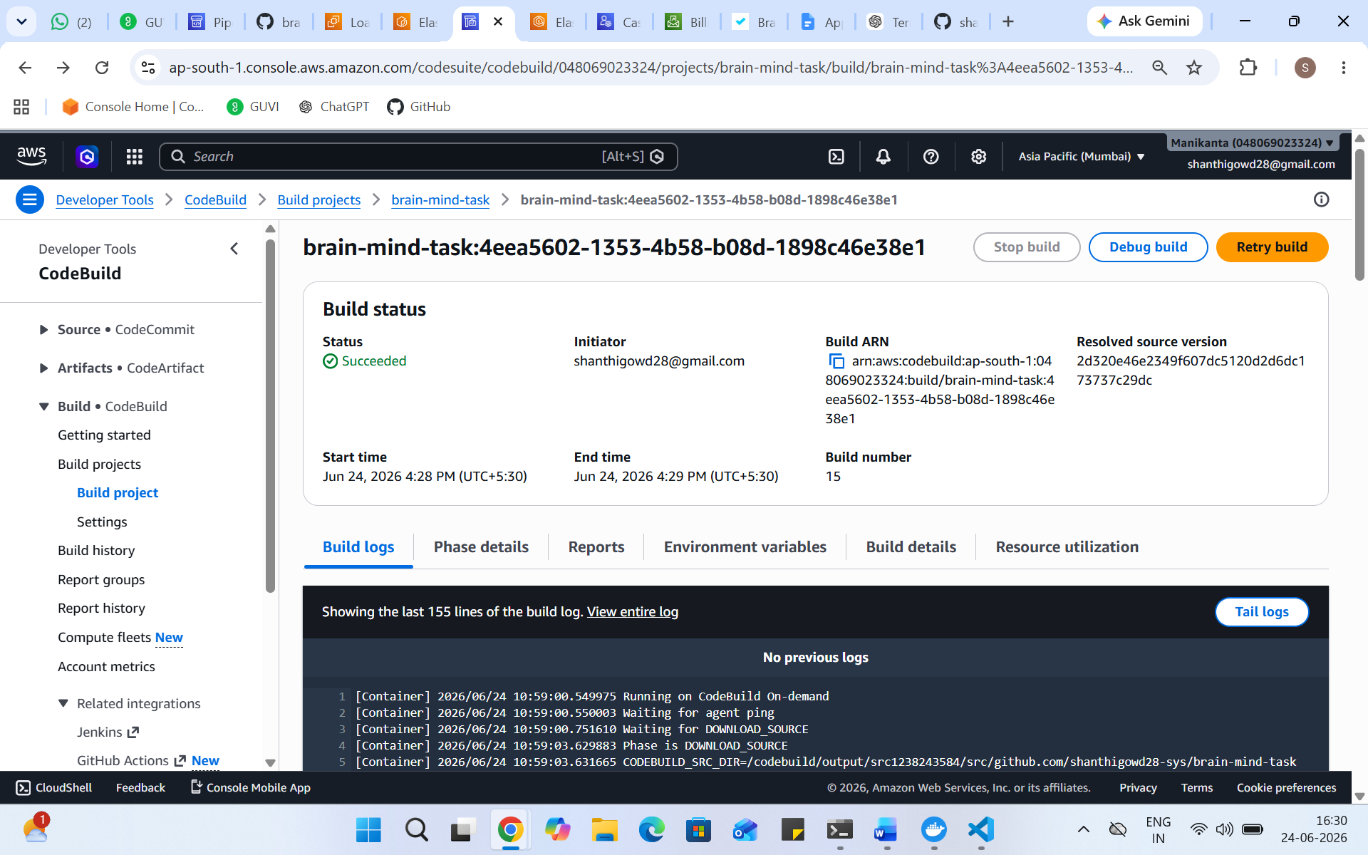
- Source: Connect to your repository
- Environment: Use managed image (Amazon Linux, Ubuntu)
- Write and define commands in buildspec.yml.
- 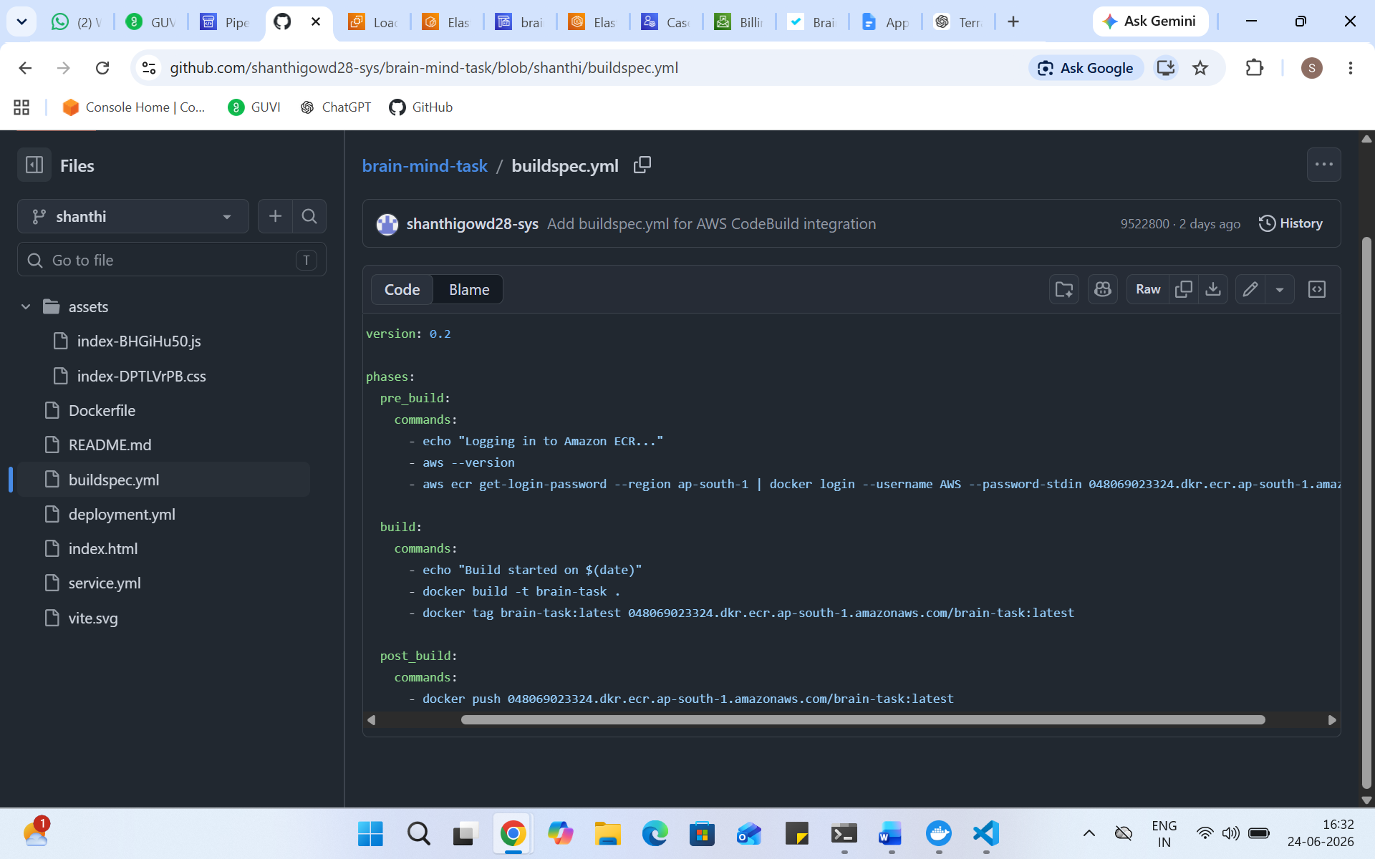

Version Control:
- Push the codebase to a Git provider (GitHub).
- 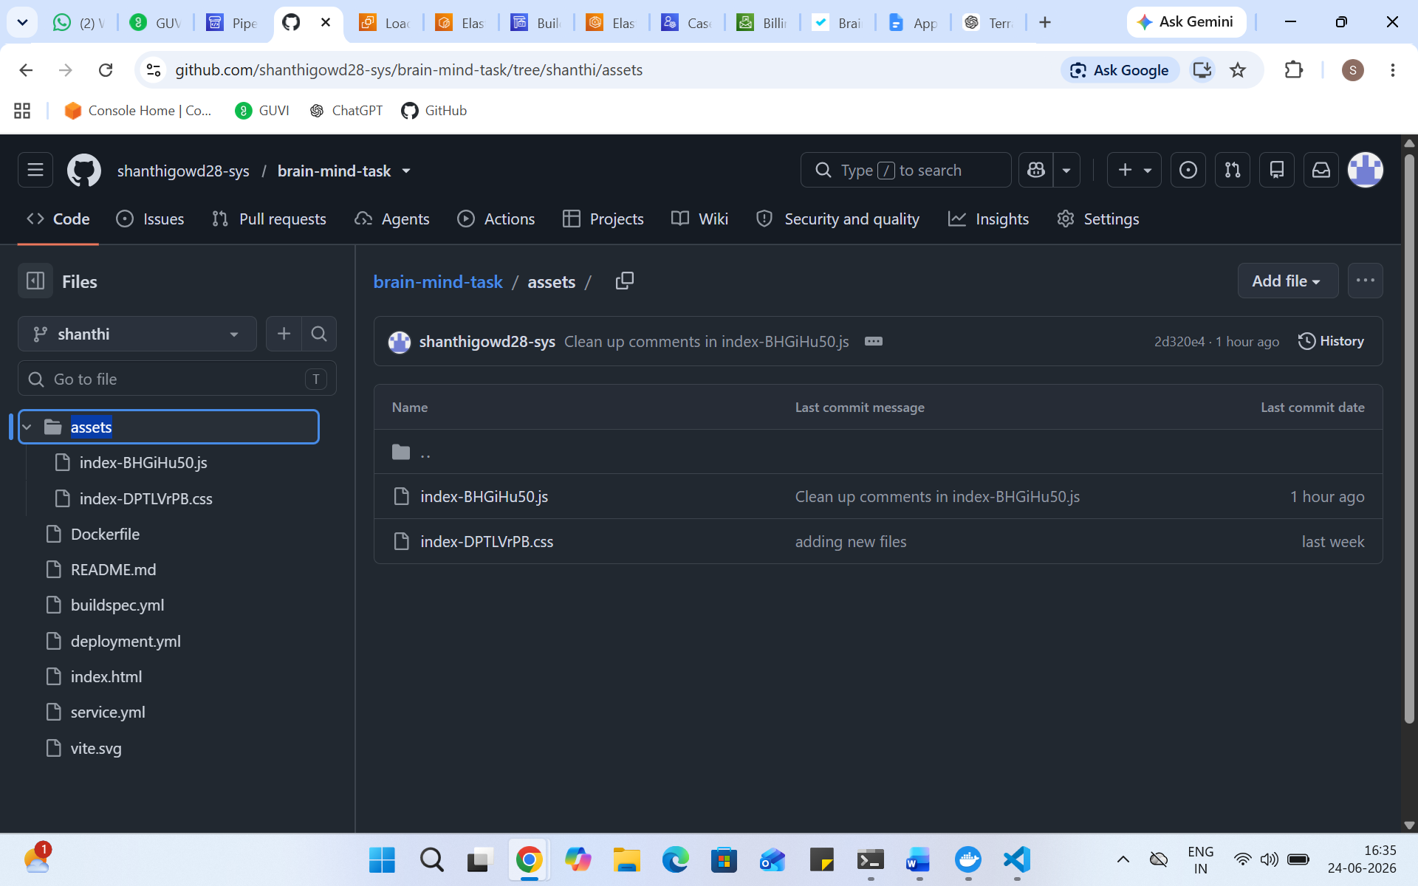
- Use CLI commands to push code.
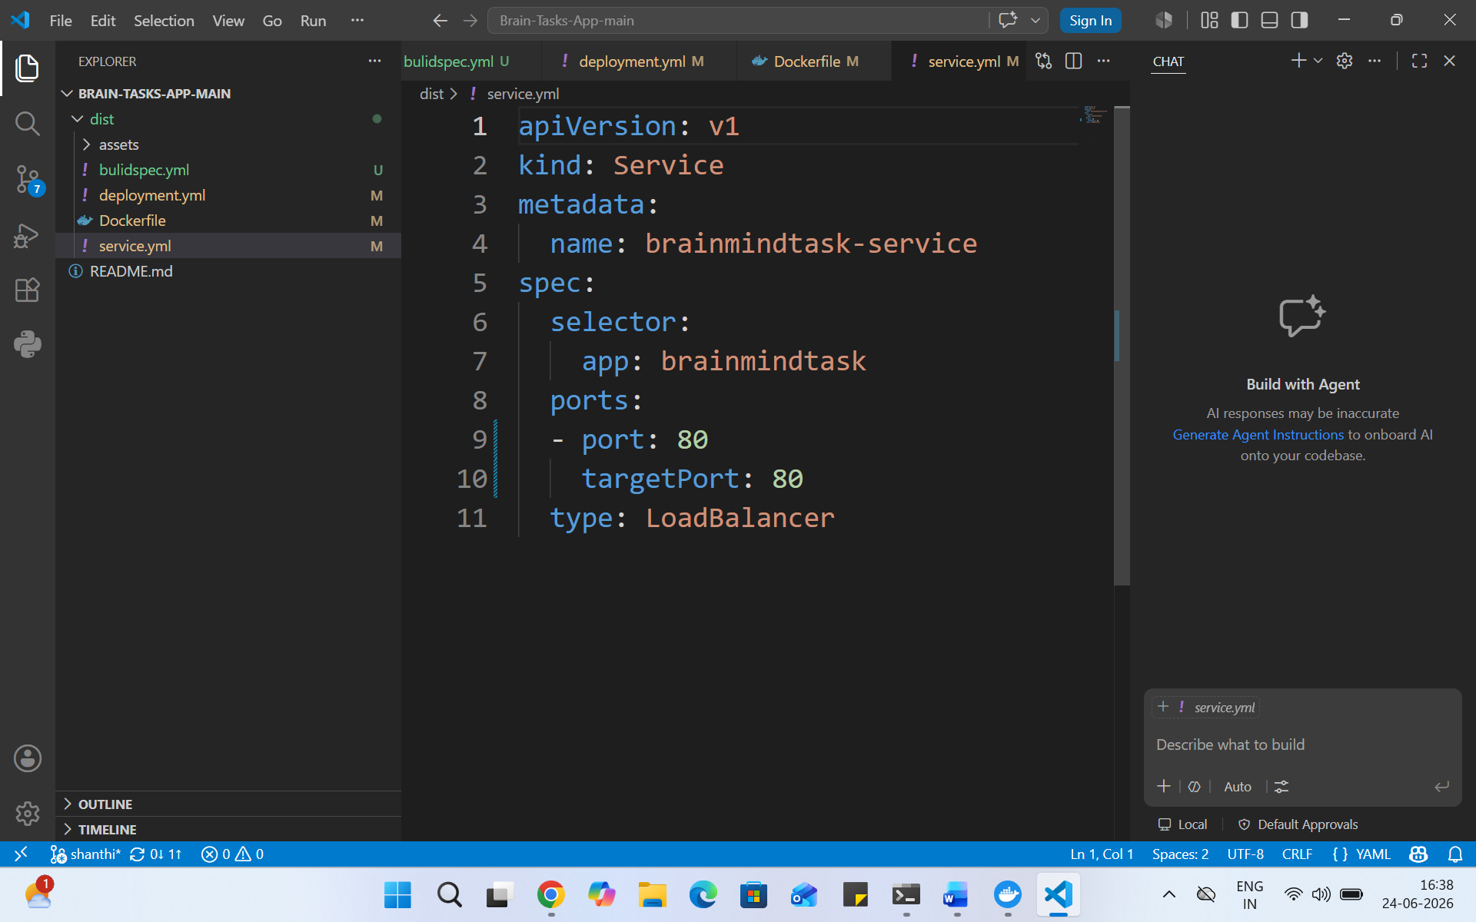
CodePipeline:
- Source: GitHub
- Build: AWS CodeBuild project
- Deploy: Deploy to EKS via Codepipeline EKS deploy stage..
- 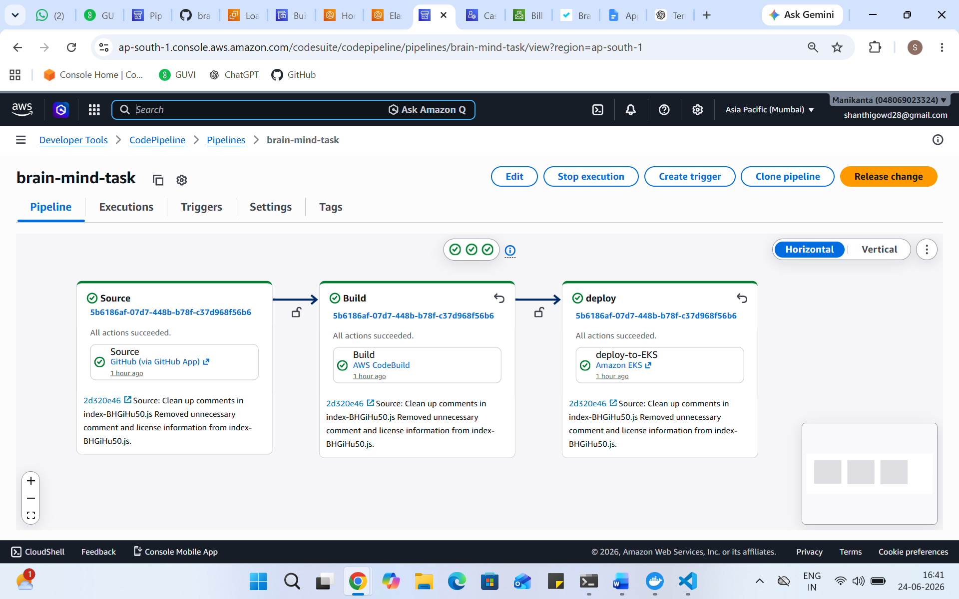

Monitoring:
- Use CloudWatch Logs to track build, deploy, and application logs.
- ś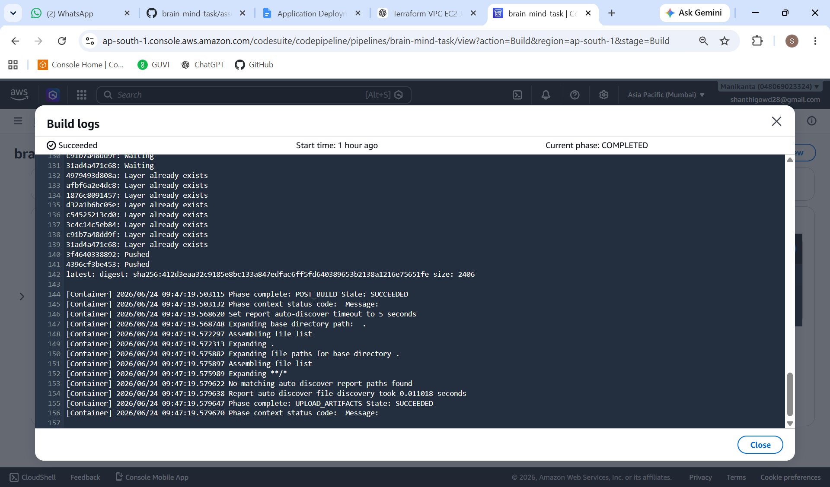
Submission Guidelines:
- GitHub Link: Submit full code repository.
- README File: Include setup instructions, pipeline explanation, and screenshots or create a document and attach all screenshots.
- Application deployed kubernetes Loadbalancer ARN.

